Faiza Abdullah

Lab 04 on MSLE Skillable Platform

ITAI 2376 Deep Learning in Artificial Intelligence

Professor: [Patricia Mcmanus](https://eagleonline.hccs.edu/courses/282423/users/264039)

**REFLECTIVE JOURNAL: EXTRACT DATA FROM DOCUMENTS IN AZURE AI FOUNDRY PORTAL**

**PROOF OF COMPLETION:**

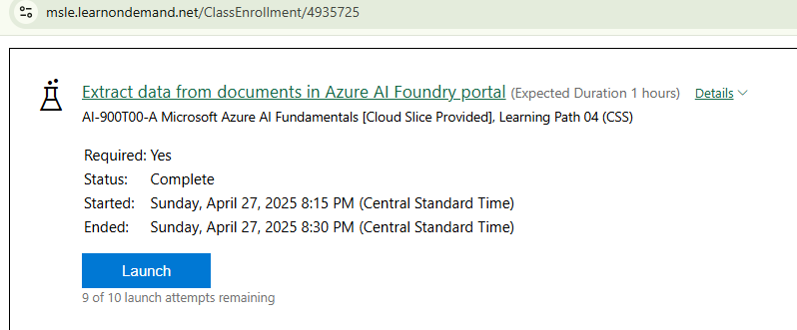

**INTRODUCTION**

This lab provided practical experience with Azure AI Document Intelligence and its ability to process unstructured data. The primary goal was to analyze and extract information from documents, specifically receipts, and identify field names and their corresponding data.

**LAB OBJECTIVES AND PROCESS**

The objectives included setting up a project in the Azure AI Foundry portal and using the Document Intelligence service to analyze a receipt.

**WHAT I DID**

* After accessing the Azure AI Foundry Portal on the Microsoft Learn on Demand platform and initiated the process by creating a new project followed by navigating to the AI Services section - Vision + Document Capabilities,

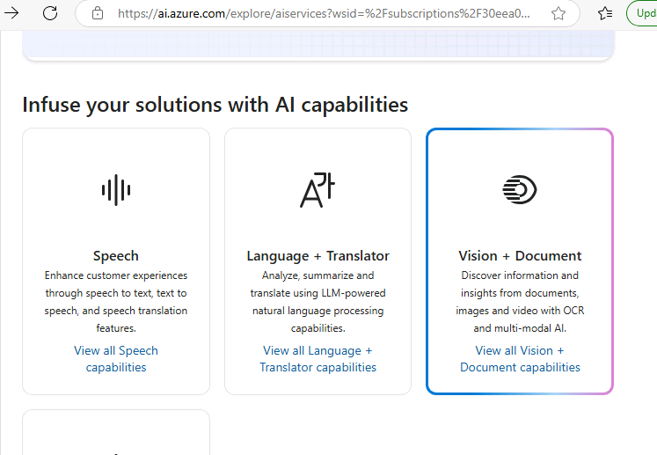

* Used Azure AI Document Intelligence to upload and analyze a sample receipt (pre-built in the model).

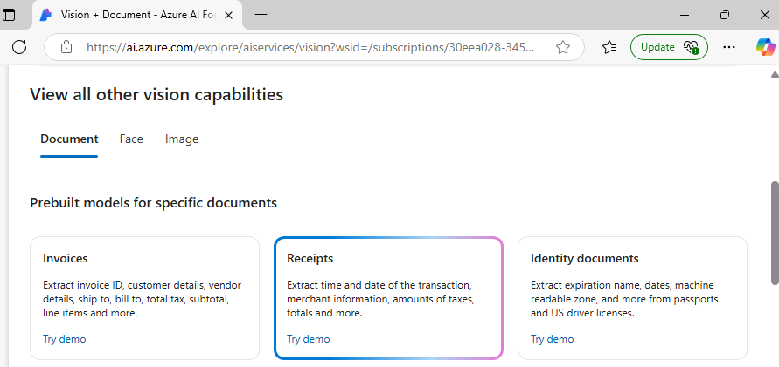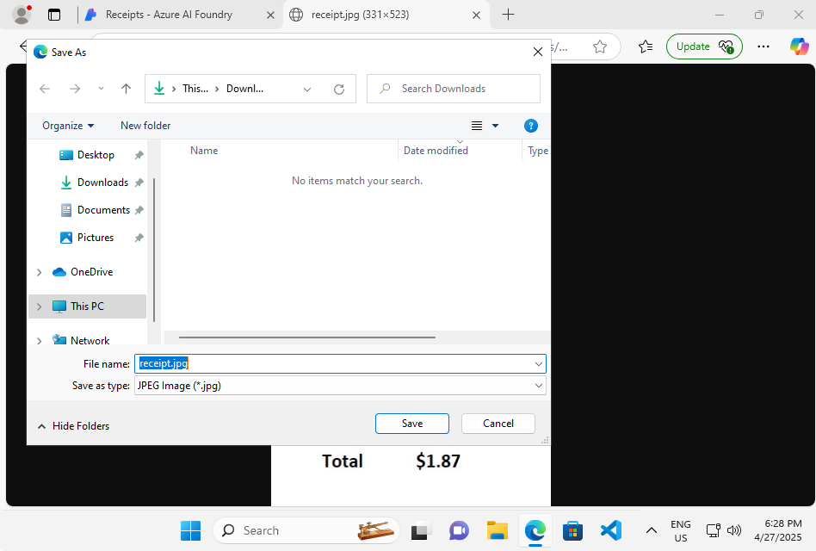

* Ran Analysis and Interpreted Results: I ran the analysis on the uploaded receipt and examined the extracted data, including merchant name, address, phone number, transaction date, line items, and totals. The service also provided confidence scores for the accuracy of the extracted information. For example, the service extracted “Northwind Traders”, “123 Main Street”, “555-123-4567”, “2/17/2020”, “1 Apple $0.90”, “1 Orange $0.80”, “Sub-Total $1.70”, “Tax $0.17”, and “Total $1.87” from the receipt.

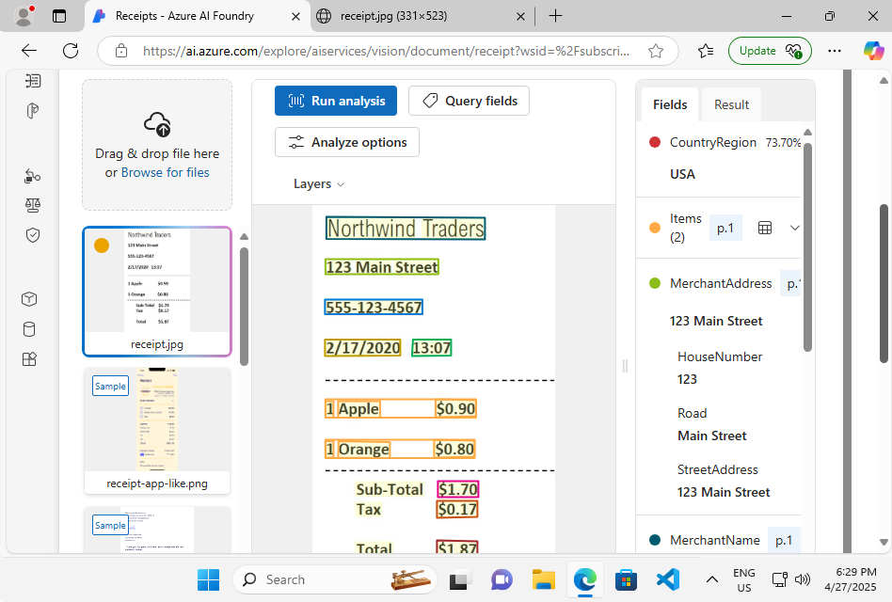

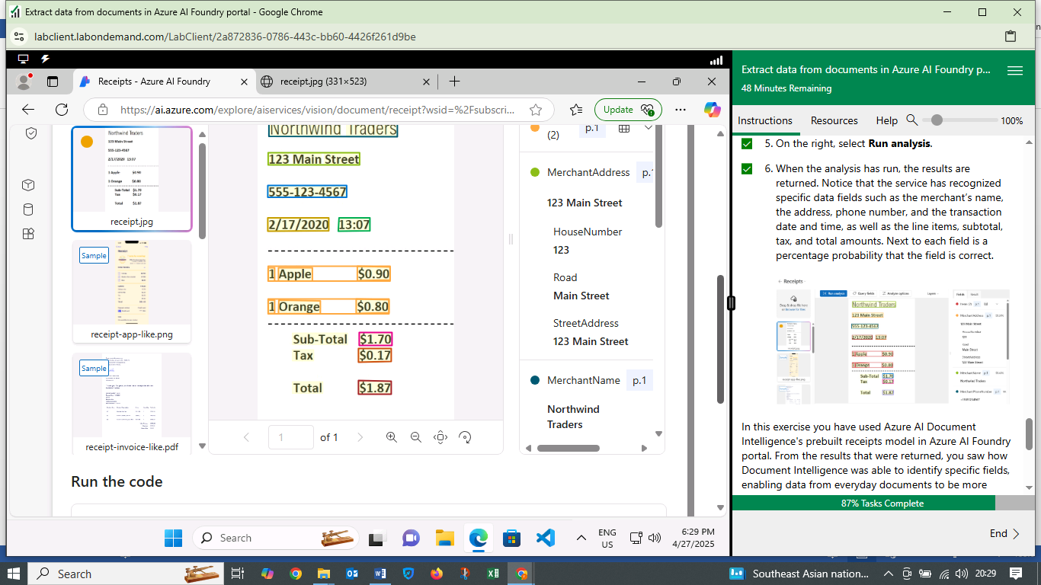

**WHAT I LEARNED**

* Capabilities of Azure AI Document Intelligence: I learned how this service can extract information from documents, understanding its ability to identify and categorize data fields.
* Prebuilt Models: The lab showcased the use of prebuilt models, like the “Receipts” model, which simplifies the process of document analysis for specific document types.
* OCR Enhancement: I understood how Document Intelligence builds upon Optical Character Recognition (OCR) by not only reading text but also structuring it for easier storage and analysis.
* Real-World Applications: The lab highlighted the practical applications of Document Intelligence in scenarios like automating data entry from receipts.

**CHALLENGES FACED**

* Navigating the Azure AI Foundry Portal: Locating the specific Document Intelligence features within the portal required some initial exploration.
* Understanding Model Specifics: Understanding the capabilities and limitations of the prebuilt “Receipts” model required careful attention to the lab instructions.
* Interpreting Results and Confidence Scores: Interpreting the extracted data and understanding the confidence scores associated with each field required a detailed review of the output.

**INSIGHTS GAINED**

* Efficiency of Document Processing: Azure AI Document Intelligence can significantly improve the efficiency of processing documents by automating data extraction.
* Data Structuring: The service's ability to structure unstructured data is crucial for downstream analysis and storage.
* Accuracy of Extraction: The confidence scores provide a measure of the accuracy of the extracted information, which is important for evaluating the reliability of the results.
* Potential for Automation: Document Intelligence has the potential to automate various business processes, such as expense reporting and invoice processing.

**CONCLUSION**

The Azure AI Document Intelligence lab enhanced understanding about document processing, data structuring, and extraction accuracy will be valuable in my future work with Azure AI technologies.